# V2X HUB Travel Time Estimation Logic

This document outlines the estimation of vehicles’ travel time for V2X Hub. In the connected environment, travel time can be directly obtained with the vehicle trajectories. The travel time in this logic is defined as the time it takes for a vehicle to traverse through a segment of a highway or a corridor with one or more intersections. Since connected vehicles are able to communicate to V2X Hub within only a certain range of the RSU location(s), the considered segment to identify the travel time cannot exceed this range. Depending on the research scope, different levels of travel time details and statistics may be obtained, including but not limited to, travel time distribution, standard deviation, and sub-segment travel times (e.g., upstream of the intersection).

## Requirements and Assumptions

* Connected vehicles are equipped with OBUs.
* Connected vehicles should be able to frequently send BSMs to V2X Hub through an RSU when entered to a certain vicinity of the RSU.

## Inputs to the Travel Time Estimation Algorithm

* BSM
  + Vehicle location
* MAP
  + Roadway geometry
* Parameters
  + RSU detection space range

## Steps to the Average Delay Estimation

As a connected vehicle enters the RSU range, V2X Hub can record its entrance time. Afterwards, the vehicle trajectory along the segment can be tracked as the vehicle traverse it. Therefore, the vehicle travel time along the entire segment or subsections of it can be obtained. With the travel time information of every connected vehicles in the system, a full distribution of travel times or an aggregate travel time measure can be estimated at any given time period. The steps below explain the algorithm to estimate the travel time distribution.

1. Create a list of sections and subsections with the information provided by the MAP message. A section is defined as a series of road segments that forms a path for a vehicle from a location it enters the RSU range to a location it exits from it. For example, there are 12 possible sections for a typical four-way intersection as each vehicle can turn right, left, or move straight at each way of the intersection (16 sections if including 4 U-turns). If the travel time of a segment sub-section is needed, the section can be broken into several subsections by defining a boundary location. For example, if the travel time information of the upstream section of an intersection is needed, then the stop bar can be set as a boundary location and thus the segment of the intersection on that specific direction is broken into two subsections. Afterwards, a boundary ID is assigned for each RSU range entrance or exit point at each direction and each point between consecutive subsections. Figure 1 shows an example of a boundary ID at the stop bar on the westbound direction and the boundary IDs at the RSU range entrance or exit points. In this figure, boundary ID 5 is assigned to the boundary location at the stop bar on the westbound direction, highlighted as red. Let denote the set of boundary IDs. With these IDs, the vehicle GPS coordinates around these locations can be mapped to the corresponding boundary IDs. Then, sections and subsections can be defined by a pair of boundary IDs. Let denote the set of sections and subsections, where are the origin and destination boundary IDs. Table 1 lists the sections and subsections for the boundary IDs shown in Figure 1. For simplicity, the U-turn movements are excluded in this table. However, these movements can also be considered. For example, {1,1} in Figure 1 represents a U-turn movement, at which a vehicle enters the RSU range on the eastbound direction, makes a U-turn at the intersection, and exits the RSU range on the westbound direction.

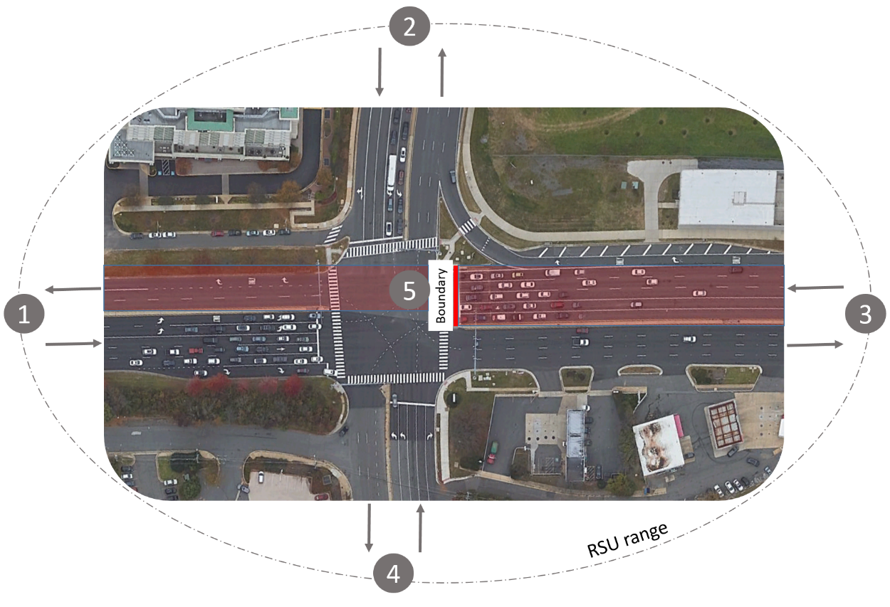

Figure 1 An example of boundary IDs.

Table 1 List of section and subsections for the example shown in Figure 1.

|  |  |  |
| --- | --- | --- |
| Section/subsection number  () | Origin boundary ID  () | Destination boundary ID  () |
|  | 1 | 4 |
|  | 1 | 3 |
|  | 1 | 2 |
|  | 2 | 1 |
|  | 2 | 4 |
|  | 2 | 3 |
|  | 3 | 2 |
|  | 3 | 5 |
|  | 4 | 3 |
|  | 4 | 2 |
|  | 4 | 1 |
|  | 5 | 1 |
|  | 5 | 4 |

1. Create a list of connected vehicles crossed a boundary. This list contains temporary vehicle IDs and the corresponding boundary IDs and timestamps. Let denote the set of vehicle IDs and the time when the vehicle with temporary ID of crosses the boundary location with ID , . could be set in the Epoch format to facilitate the travel time calculations. Figure 2 shows an example of this list for two vehicles entering the RSU range at almost the same time.

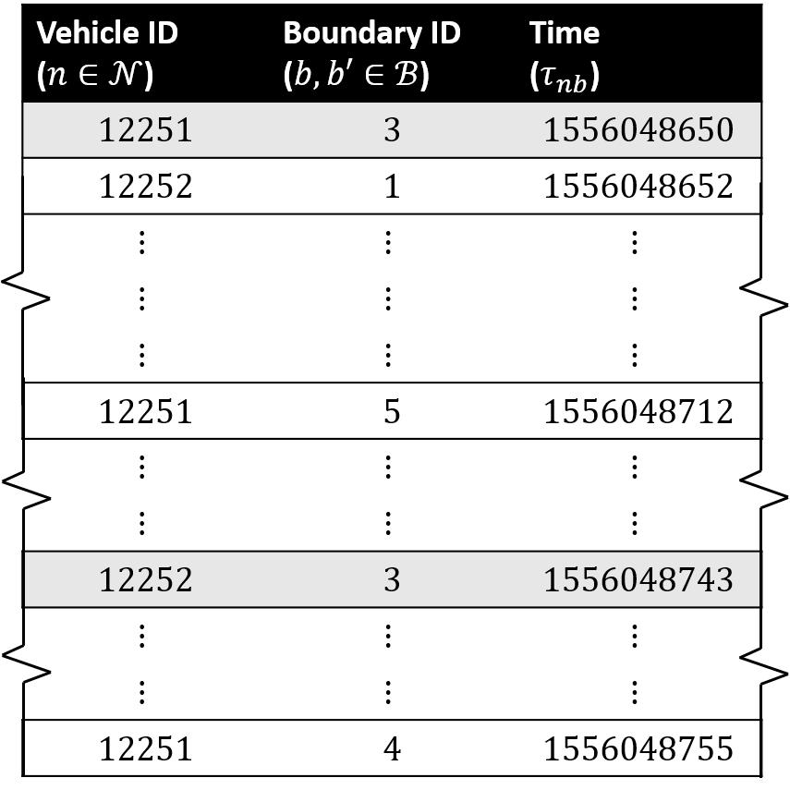

Figure 2 An example list of connected vehicle.

1. Create a list of section/subsection travel times. Let denote the section/subsection travel time of the vehicle with the temporary ID of that is calculated as

Figure 3 shows an example of this list for the vehicle list shown in Figure 2. For example, the first path in the figure below is related to vehicle ID traveling from boundary ID to boundary ID (see figure above) and the corresponding travel time is calculated as s.

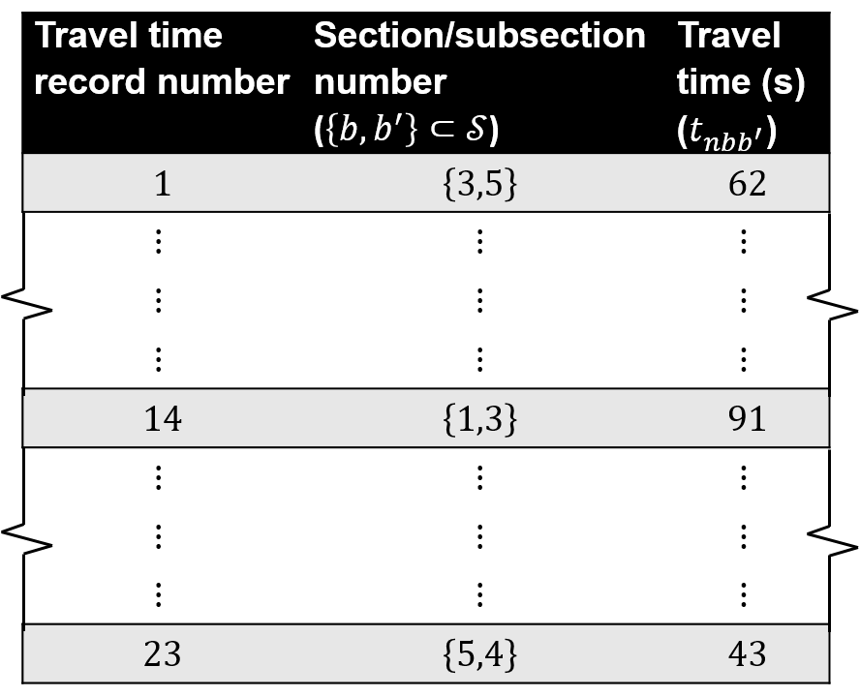

Figure 3 An example list of travel times.

1. Update the list of connected vehicles and the corresponding attributes as a connected vehicle crosses a boundary, i.e., enters the RSU range, exits the RSU range (recorded as the last identified time around the exit boundaries), or crosses the subsection boundaries.
2. Update the travel time list as a connected vehicle exits the RSU range or crosses a subsection boundary.
3. Calculate the average travel times for different time intervals. With the list of travel times, average travel time measures for each section/subsection can be calculated on different time intervals (i.e., 5-minute, 15-minute, hourly, etc.). For example, at every 5 minute, an average travel time can be determined by making an average of all travel time records within the last 5-minute interval for each section/subsection.